Matt Matuk

CSIT – 211

5 February 2015

Extra Credit

**Programming Project PP 10.7**

-----**SPEC**-----

Suppose a library is processing an input file containing the titles of books in order to remove duplicates. Write a program that reads all of the titles from an input file called *bookTitles.inp* and writes them to an output file called *noDuplicates.out.* When complete, the output file should contain all unique titles found in the input file.

**SCRUM**

* Class RemoveDuplicateBookTitlesPanel
  + Main method
    - Create the Frame for the GUI
  + Method Constructor
    - Three Buttons
      * removeDuplicates
      * startingFileSelect
      * endingFileSelect
    - Two text fields
      * textFieldSatringFile
      * textFieldEndingFile
* Class NoDuplicates
  + FileReader
  + Bufferedreader
  + PrintWriter
  + Method readFile(String inFileName String outFileName)
  + Method removeDuplicates(String bookTile, String outFileName)
* GUI
  + Button to begin the removal of duplicates
  + Button to select the staring file
  + Button to select the ending file location
  + Error Message if bookTitles.inp is not found
  + Error Message if noDuplicates.out is not found
  + Two text fields displaying the starting and ending files
  + Display message when program is running
  + Display message when program has removed all duplicates

**GUI Storyboard**

1. Use a message dialog box to display the error message if the files cannot be found or if the user presses the Remove Duplicates button before picking two files.
2. Use a message dialog box to display a message saying “Removing Duplicate Titles. Please do not exit the program.”. Display this message when the user presses the Remove Duplicates button and chose two valid files
3. Use a message dialog box to display “Done.” When all titles have been removed.

**Class: RemoveDuplicatesFrame**

1. This class contains all the panels for the No duplicates program.
2. The class has listeners for buttons and allow the user to select two file locations and press the remove duplicates button to remove any duplicate strings the file.
3. All colors and sizes of the panel can be change to make to look better. Use best judgment.
4. All method are public and void unless otherwise noted
5. All variables are protected unless otherwise noted

**Import**

**Process**

* Variables
  + File
    - fileStart
    - fileEnd
* Method Constructor
  + Set the layout as box Y axis
  + Create three button for the removing duplicates, starting file choice and ending file location.
    - btnRemove “Remove Duplicates”
    - btnStartFile “File”
    - btnEndFile “File”
  + Create two text fields for the two file locations. Make sure the text fields are not editable by the user.
    - textFieldStartFile
    - textFieldEndFile
  + Create three labels for the intro, info for the starting file and info for the ending file locations.
    - labelIntro “Welcome to the application. This application will take a list of book titles and remove any duplicates.”
    - labelStartFile “Please select the starting file location. The file must be called “bookTitles.inp””
    - labelEndFile “Please select the ending file location. The file will be named “noDuplicates.out””
  + Create three new JPanels for each of the three areas of the GUI
    - panelIntro
      * This panel contains the intro statements from the labelIntro and will be at the top of the main panel.
    - panelFiles
      * This panels contains the two text fields, the two file buttons, and the two file labels. Make sure to align each item from top to bottom and make sure it look like the GUI Storyboard and will be in the middle of the other two panels inside the main panel.
    - panelStart
      * This panel will contain a black border and will be at the bottom of the main Panel
  + Create a new button listener called *listener* and add all three buttons to that listener.
  + Add the three panels to the main panel in the order of panelIntro first. Then panelFiles. Then panelStart.
  + **Class called ButtonListener the implements the ActionListener (This class will contain the actions for each button)**
    - Method actionPerformed (Pass the method an ActionEvent named buttonPressed)
      * Use three IF statements to determine which button is pressed by using the getSorce() method on the action
        + If the removeDuplictions button is pressed

Check to see if a starting and ending file location has been chosen. If either location is empty, then use a message dialog box to display a error message telling the user to choose both locations for the files before continuing.

If both files have been chosen

Display a message dialog box telling the user that the duplicate book titles are being removed.

Create new NoDuplicates object and pass it fileStart and fileEnd variables

Display a message dialog box saying done when all duplicates are removed.

* + - * + If btnStartFile is pressed

Use a file chooser to allow the user to pick a file

The file name must be called “bookTitles.inp” any other names or file types need to have an error message displayed telling the user to re-pick

Set fileStart = to the file chosen

* + - * + If btnEndFile is pressed

Use a file chooser to ask the user to select a location for the noDuplicates.out file to be saved too

Set fileEnd = to the location where the user picked and make sure save the file as noDuplicates.out to the end of the location picked

**Class: NoDuplicates**

1. This class contains the methods need to remove duplicate strings from a file and save it to a new file
2. All methods are public and void unless otherwise noted
3. All variables are protected unless otherwise noted

**Import**

* Java.io.BufferedReader
* Java.io.FileReader
* Java.io.IOException

**Process**

* Method Costructor()
  + Does nothing
* Method readFile(String *inFileName* String *outFileName*)
  + This method will accepet two parameters which will be for the inout and output file locations
  + Create a new FileReader named *fileReader* and pass it the *inFileName*
  + Create a new BufferedReader named *bufferedReader* and pass it the *fileReader*
  + String *line* = null
  + Use a While loop to loop threw the lines of the input file (*line = bufferedReader.readLine()* is not null)
    - Call the method removeDuplicates and pass the method the bufferedReader string and the outFileName string
  + Close the readers
* Method private removeDuplicates(String bookTitle, String outFileName)
  + This method will accept a parameter which will be for the output file location
  + Create a new FileReader named *outFileReader* and pass it the *outFileName*
  + Create a new BufferedReader named *outBufferedReader* and pass it the *fileReader*
  + Create a new PrintReader named *printReader* with the output file location
  + String *outLine* = null
  + Use a While loop to loop threw the output file and check to see if there is a duplicate title name (outLine = *outBufferedReader.readLine()* is not null)
    - If *outLine* is equal to *bookTitle,* then break out of the while loop
  + If outLine is null
    - Add the String outLine to the end of the output file

**CODE**

//************************************************************************

// RemoveDuplicatesFrame.java Matt Matuk

// CSIT 211 Project 10.7 pg 463

// 1. This class contains all the panels for the No duplicates program.

// 2. The class has listeners for buttons and allow the user to

// select two file locations and press the remove duplicates button to

// remove any duplicate strings the file.

// 3. All colors and sizes of the panel can be change to make to look

// better. Use best judgment.

// 4. All method are public and void unless otherwise noted

// 5. All variables are protected unless otherwise noted

//*************************************************************************

**import** java.awt.*;

**import** javax.swing.*;

**import** javax.swing.border.LineBorder;

**import** java.awt.event.*;

**import** java.io.File;

**import** java.io.IOException;

**public** **class** RemoveDuplicatesFrame {

**private** JFrame frame;

**private** JTextField textFieldStartFile;

**private** JTextField textFieldEndFile;

**protected** File fileStart; // location of the starting file

**protected** File fileEnd; // location of the ending file

**protected** JButton btnRemove, btnStartFile, btnEndFile;

**protected** JLabel lblIntro, lblStartFile, lblEndFile;

**protected** **final** String startFileName = "bookTitles.inp"; //name for the starting file . User must enter this as the file name

**protected** **final** String endFileName = "noDuplicates.out"; //name for the ending file. user must enter this as the file name

//-------------------------------------------------------------------

// Main method. Creates the main frame for the GUI

//-------------------------------------------------------------------

**public** **static** **void** main(String[] args) {

EventQueue.*invokeLater*(**new** Runnable() {

**public** **void** run() {

**try** {

RemoveDuplicatesFrame window = **new** RemoveDuplicatesFrame();

window.frame.setVisible(**true**);

} **catch** (Exception e) {

e.printStackTrace();

}

}

});

}

//-------------------------------------------------------------------

// Constructor Method. Nothing needed.

//-------------------------------------------------------------------

**public** RemoveDuplicatesFrame() {

initialize();

}

//-------------------------------------------------------------------

// This method creates all the GUI elements and the listeners for

// the buttons

//-------------------------------------------------------------------

**private** **void** initialize() {

frame = **new** JFrame("Remove Duplicate Book Titles");

frame.getContentPane().setBackground(Color.***WHITE***);

frame.setBounds(100, 100, 700, 200);

frame.setDefaultCloseOperation(JFrame.***EXIT_ON_CLOSE***);

frame.getContentPane().setLayout(**null**);

frame.setMinimumSize(**new** Dimension(700,200));

frame.setLocationRelativeTo(**null**);;

btnRemove = **new** JButton("Remove Duplicates");

btnRemove.setBounds(275, 120, 150, 25);

frame.getContentPane().add(btnRemove);

JPanel panel = **new** JPanel();

panel.setBackground(Color.***WHITE***);

panel.setBorder(**new** LineBorder(**new** Color(0, 0, 0), 2));

panel.setBounds(12, 26, 658, 90);

frame.getContentPane().add(panel);

panel.setLayout(**null**);

// label for the starting location file

lblStartFile = **new** JLabel("Please select the starting file "

+ "location. The file must be called \u201CbookTitles.inp\u201D");

lblStartFile.setBounds(5, 5, 540, 15);

panel.add(lblStartFile);

// text feild where the location of the file will be displayed

textFieldStartFile = **new** JTextField();

textFieldStartFile.setEditable(**false**);

textFieldStartFile.setBounds(5, 20, 540, 15);

panel.add(textFieldStartFile);

textFieldStartFile.setColumns(10);

// label for the ending file

lblEndFile = **new** JLabel("Please select the ending file "

+ "location. The file will be named "

+ "\u201CnoDuplicates.out\u201D");

lblEndFile.setBounds(5, 45, 540, 15);

panel.add(lblEndFile);

// text field where the ending file location will be displayed

textFieldEndFile = **new** JTextField();

textFieldEndFile.setEditable(**false**);

textFieldEndFile.setColumns(10);

textFieldEndFile.setBounds(5, 65, 540, 15);

panel.add(textFieldEndFile);

// button to select the starting file location

btnStartFile = **new** JButton("File");

btnStartFile.setBounds(550, 21, 100, 15);

panel.add(btnStartFile);

// button to select the ending file save location

btnEndFile = **new** JButton("File");

btnEndFile.setBounds(550, 66, 100, 15);

panel.add(btnEndFile);

// Intro statments

lblIntro = **new** JLabel("Welcome to the application. "

+ "This application will take a list of book titles "

+ "and remove any duplicates");

lblIntro.setBounds(12, 0, 658, 27);

frame.getContentPane().add(lblIntro);

// creates the listeners for each button

ButtonListener listener = **new** ButtonListener();

btnEndFile.addActionListener(listener);

btnRemove.addActionListener(listener);

btnStartFile.addActionListener(listener);

}

//-------------------------------------------------------------------

// This class contains all the actions for each buttton

//-------------------------------------------------------------------

**private** **class** ButtonListener **implements** ActionListener {

**public** **void** actionPerformed(ActionEvent buttonPressed) {

// When the Remove Duplicates button is pressed. if the

// user entered a open and save file, then the method

// readFile() is called to remove any duplicate titles

**if** (buttonPressed.getSource() == btnRemove) {

**if** (fileStart != **null** && fileEnd != **null**) {

JOptionPane.*showMessageDialog*(**null**, "Please wait "

+ "while the duplicate book titles are "

+ "removed.");

NoDuplicates remove = **new** NoDuplicates();

**try** {

remove.readFile(fileStart, fileEnd);

} **catch** (IOException e) {

e.printStackTrace();

}

JOptionPane.*showMessageDialog*(**null**, "DONE");

}

**else** {

JOptionPane.*showMessageDialog*(**null**, "Please "

+ "Select both a starting and an ending file "

+ "location.");

}

}

**else** {

JFileChooser chooser = **new** JFileChooser();

// When the user pushes the file button for the starting

// file location, a file chooser is displayed for the

// user to pick a file to open. File must be named

// "bookTitles.inp or an error message will be displayed

**if** (buttonPressed.getSource() == btnStartFile) {

**int** status = chooser.showOpenDialog(**null**);

**if** (status != JFileChooser.***APPROVE_OPTION***) {

textFieldStartFile.setText(

"No File Chosen!");

}

**else** {

**if**(startFileName.equals(chooser.getName(

chooser.getSelectedFile()))) {

fileStart = chooser.getSelectedFile();

textFieldStartFile.setText(

fileStart.getAbsolutePath());

}

**else** {

JOptionPane.*showMessageDialog*(**null**, "Error "

+ "Invalid File Name!");

}

}

}

// When the user pushes the file button to select a

// location to save the new file without any duplicates.

// File must be saved as "noDuplicates.out" or an error

// message is displayed

**else** {

**int** status = chooser.showSaveDialog(**null**);

**if** (status != JFileChooser.***APPROVE_OPTION***) {

textFieldEndFile.setText(

"No File Chosen!");

}

**else** {

**if** (endFileName.equals(chooser.getName(

chooser.getSelectedFile()))) {

fileEnd = chooser.getSelectedFile();

textFieldEndFile.setText(

fileEnd.getAbsolutePath());

}

**else** {

JOptionPane.*showMessageDialog*(**null**, "Error "

+ "Invalid File Name! Please Name "

+ "the file \"noDuplicates.out\"");

}

}

}

}

}

}

}

//************************************************************************

// NoDuplicates.java Matt Matuk

// CSIT 211 Project 10.7 pg 463

// 1. This class contains the methods need to remove duplicate strings

// from a file and save it to a new file

// 2. All methods are public and void unless otherwise noted

// 3. All variables are protected unless otherwise noted

//*************************************************************************

**import** java.io.BufferedReader;

**import** java.io.BufferedWriter;

**import** java.io.File;

**import** java.io.FileReader;

**import** java.io.FileWriter;

**import** java.io.IOException;

**import** java.io.PrintWriter;

**public** **class** NoDuplicates {

//-------------------------------------------------------------------

// Constructor Method. Nothing needed.

//-------------------------------------------------------------------

**public** NoDuplicates() {

}

//-------------------------------------------------------------------

// This method will accept two files. A starting file that contains

// a list of duplicate strings. The Second file will be the location

// and file that will contain the list of strings with out duplicates.

//

// Does not sort the list. Only removes the duplicate strings.

//-------------------------------------------------------------------

**public** **void** readFile(File inFileName, File outFileName)

**throws** IOException {

BufferedReader bufferedReader = **null**;

**try** {

bufferedReader = **new** BufferedReader(

**new** FileReader(inFileName));

String line = **null**;

// Loops for each line in the staring file.(Each string)

**while** ((line = bufferedReader.readLine()) != **null**) {

removeDuplicates(line, outFileName);

}

} **catch** (IOException NoFileFound) {

System.***out***.println("Error. No File Found.");

} **finally** {

// closes BufferedReader if the reader was open

**if** (bufferedReader != **null**) {

bufferedReader.close();

}

}

}

//-------------------------------------------------------------------

// This method will create the ending file that contains no duplicate

// strings. The method will accept a string for the string that is

// being compared and the method will accept a File for the ending

// file without any duplicates.

//-------------------------------------------------------------------

**private** **void** removeDuplicates(String bookTitle, File outFileName)

**throws** IOException {

PrintWriter outPrintWriter = **null**;

BufferedReader outBufferedReader = **null**;

**try** {

// New file writer the will append to the ending file so strings

// can be added to the end each time.

outPrintWriter = **new** PrintWriter(

**new** BufferedWriter(**new** FileWriter(outFileName, **true**)));

outBufferedReader = **new** BufferedReader(

**new** FileReader(outFileName));

String outLine = **null**;

// Loops threw the ending file for each item in the file(Line) and

// compares the line to the string that was passed. Breaks the loop

// if the two strings match.

**while** ((outLine = outBufferedReader.readLine()) != **null**) {

**if** (outLine.equalsIgnoreCase(bookTitle)) {

**break**;

}

}

// Adds the passed string if there was no identical string in the

// ending file.

**if** (outLine == **null**) {

outPrintWriter.println(bookTitle);

}

} **catch** (IOException NoEndingFile) {

System.***out***.println("Error. File Not Found."

+ NoEndingFile.getStackTrace());

} **finally** {

**if** (outPrintWriter != **null**) {

outPrintWriter.close();

}

**if** (outBufferedReader != **null**) {

outBufferedReader.close();

}

}

}

}

**OUTPUT SCREEN**

* Starting program.

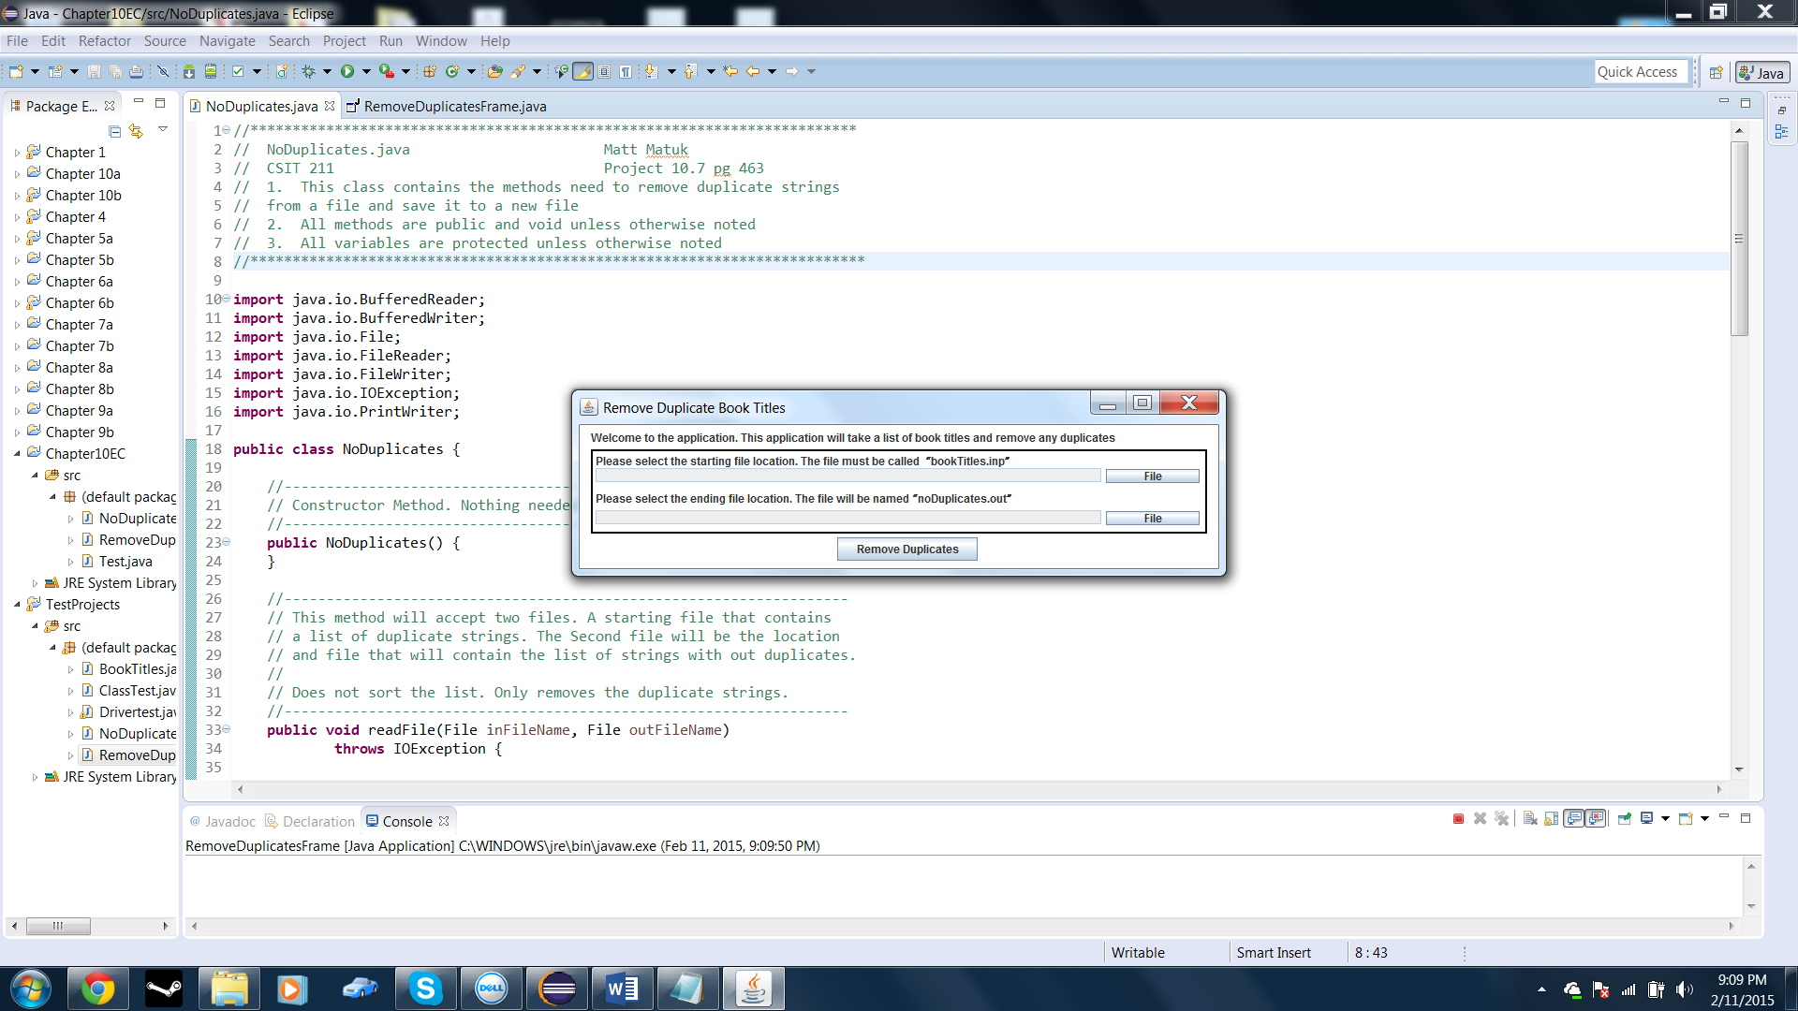

* Open File button pressed.

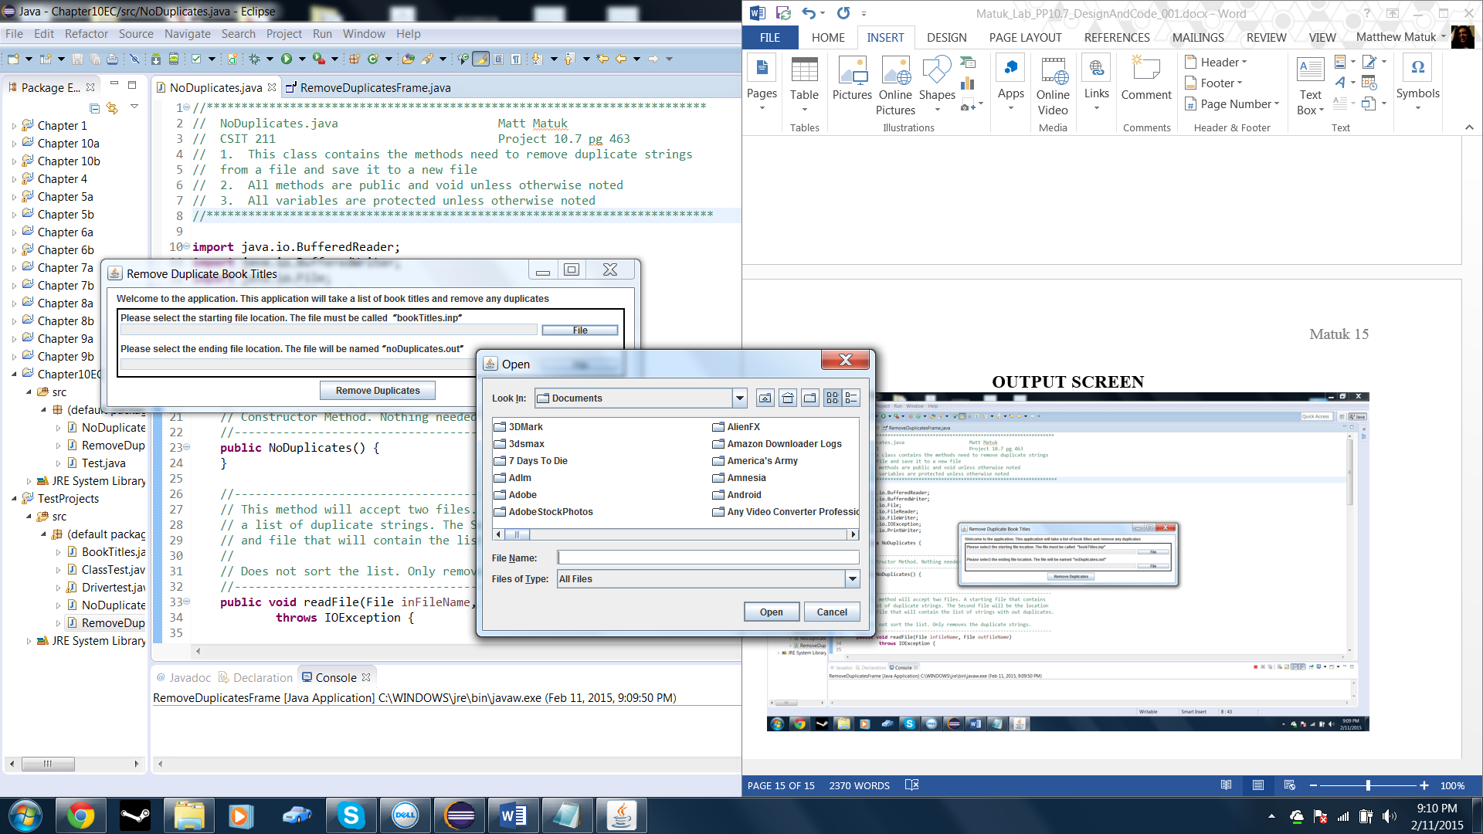

* Error message displayed when trying to open a file not named “bookTitles.inp”

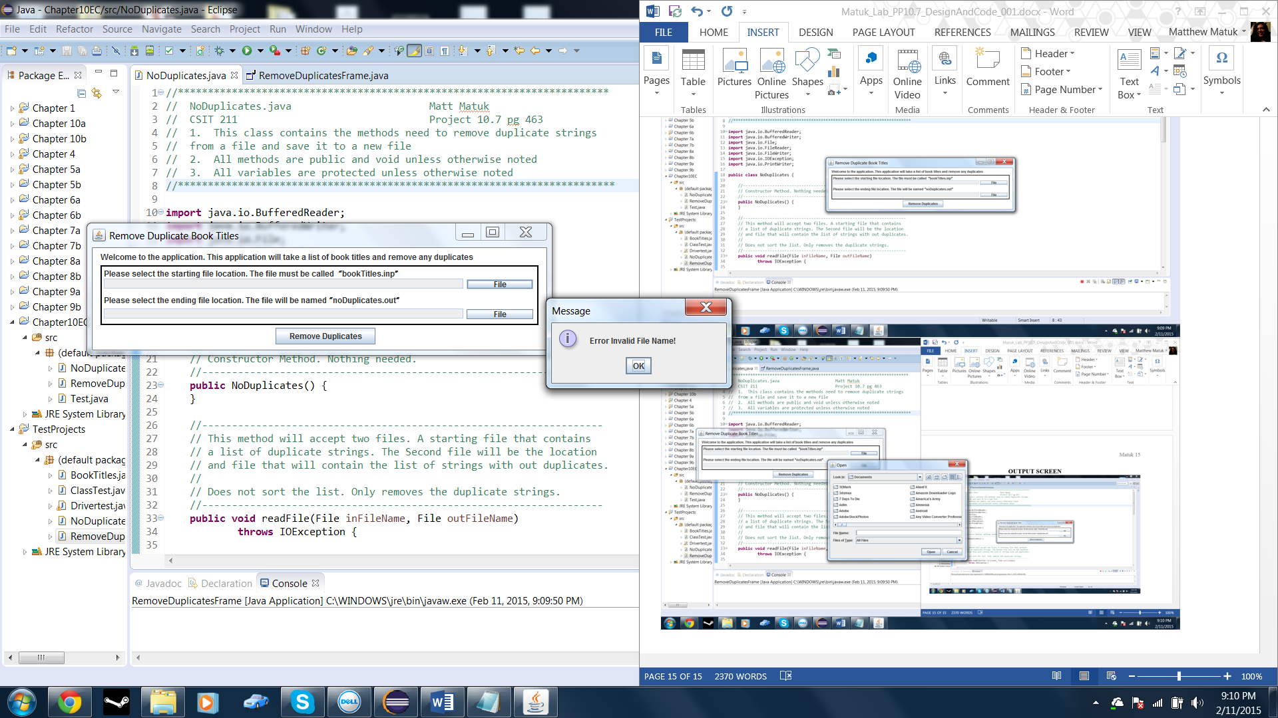

* Opening the correct named file.

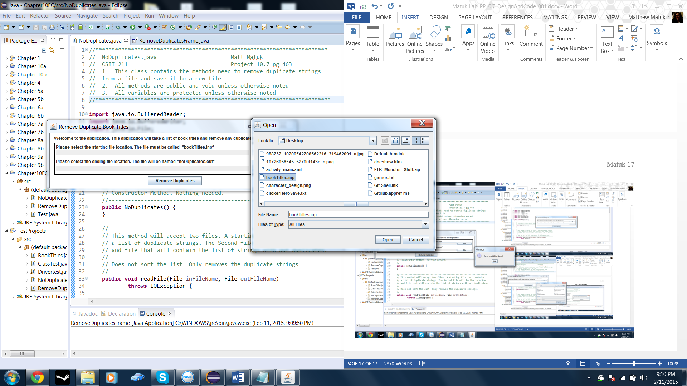

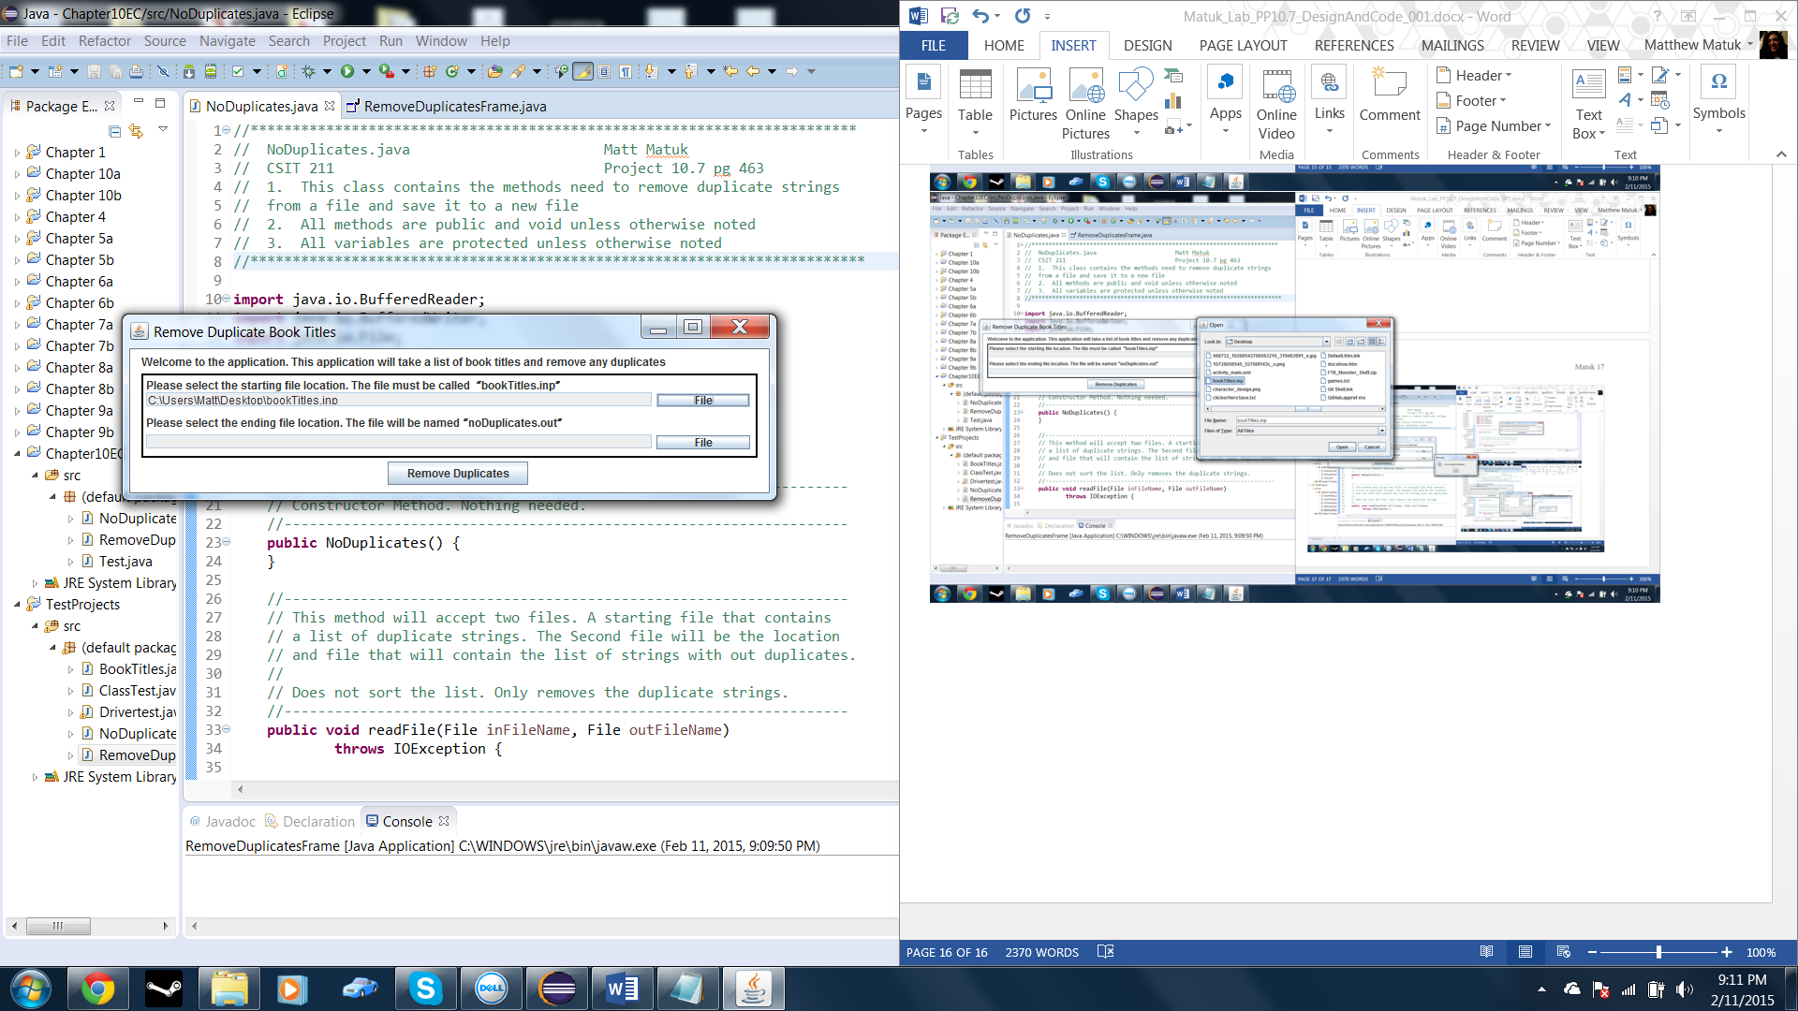

* Error message being displayed when trying to select a save location and not naming the save file “noDuplicates.out”

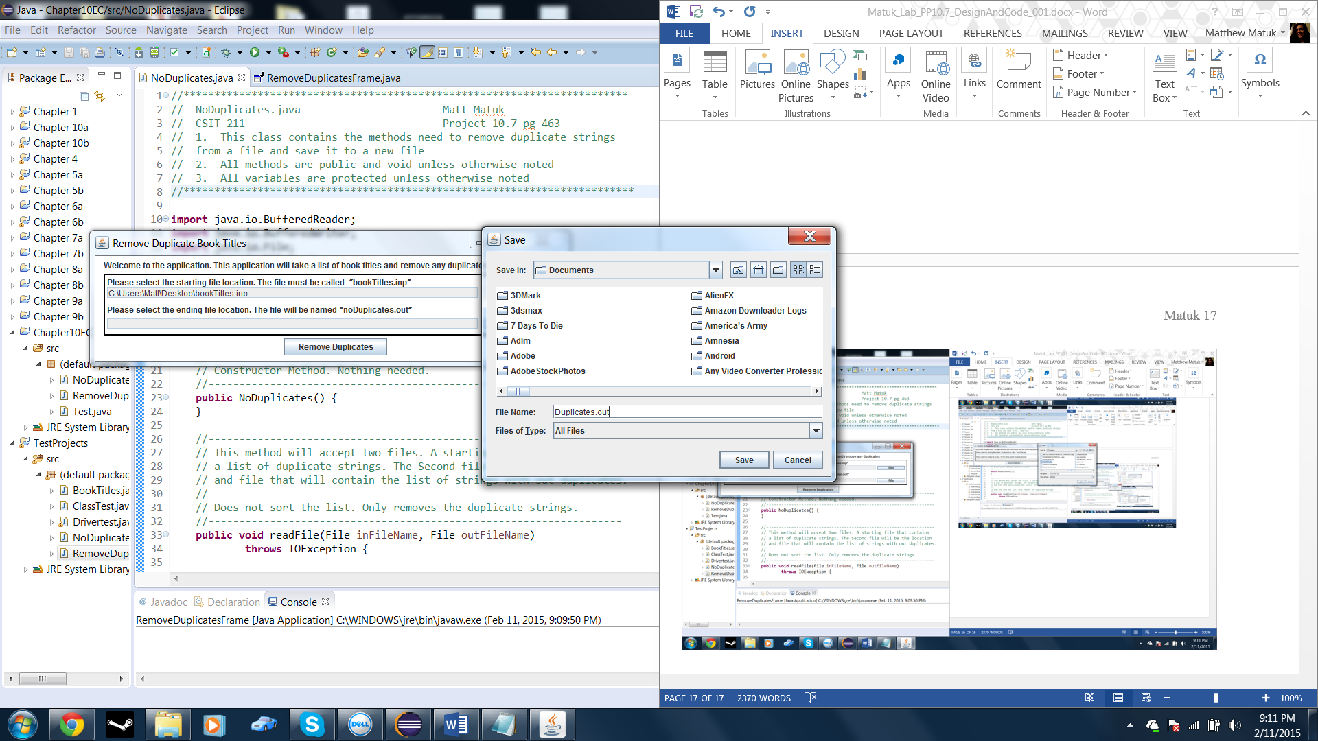

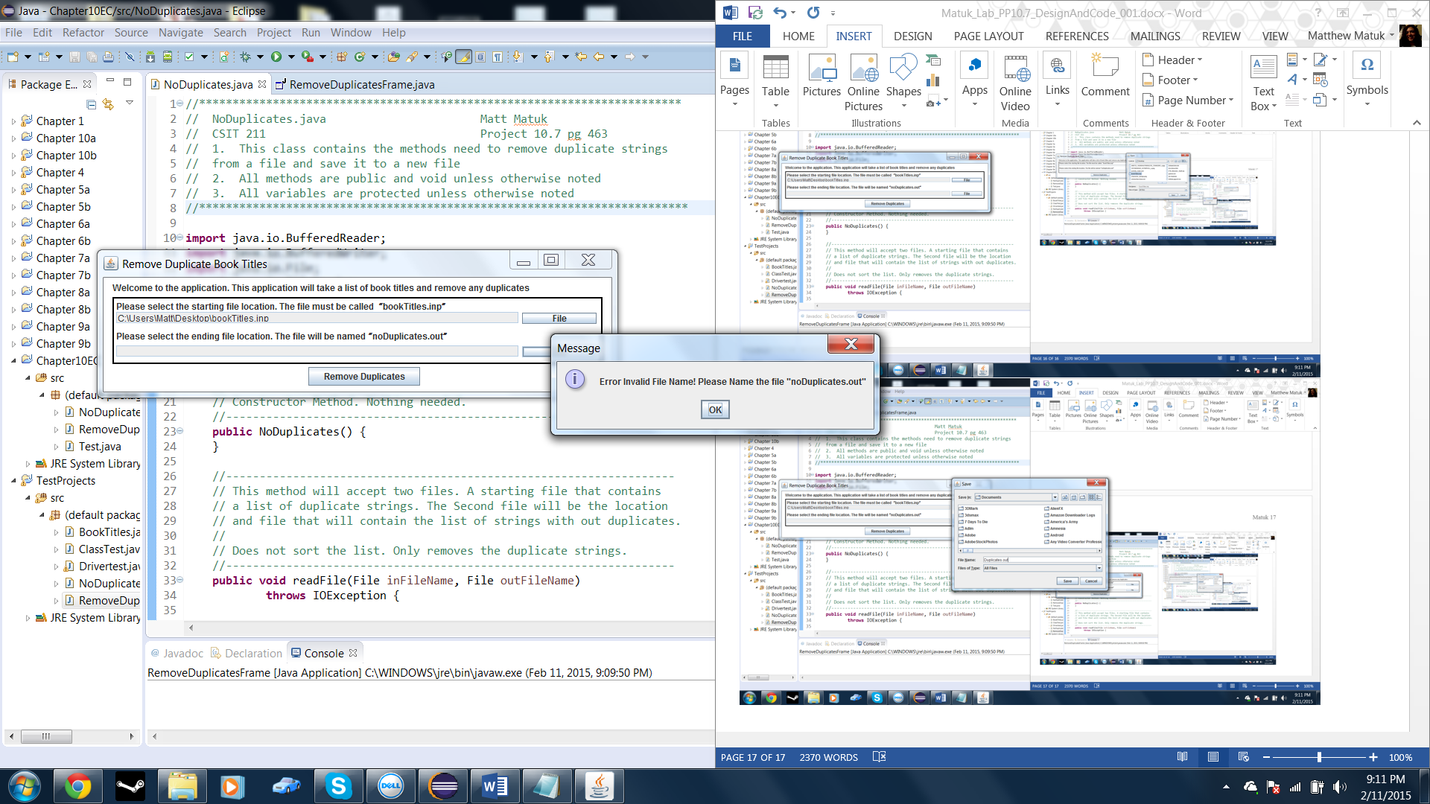

* Correctly naming the save file.

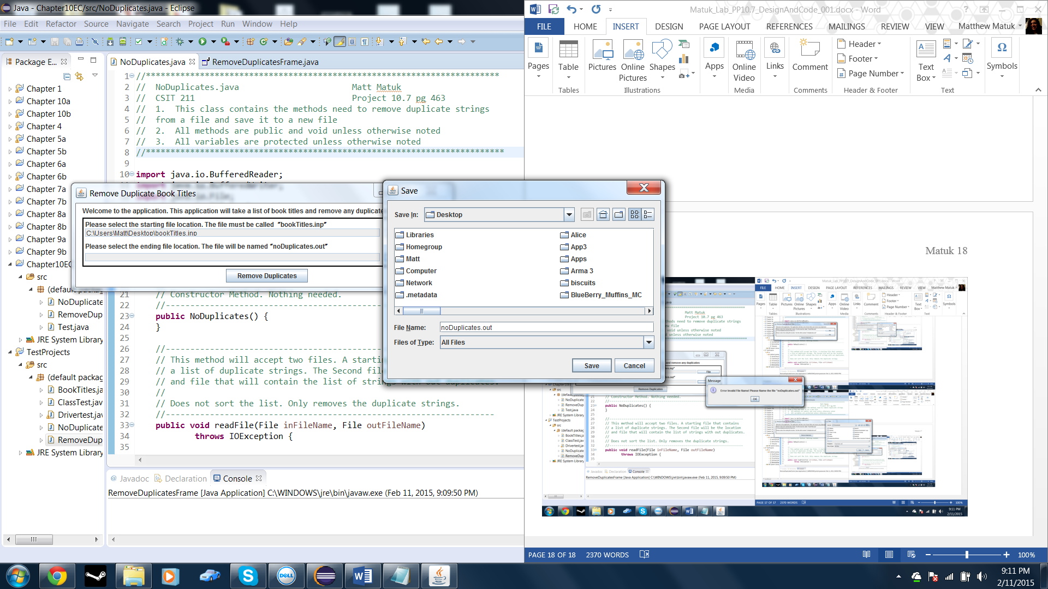

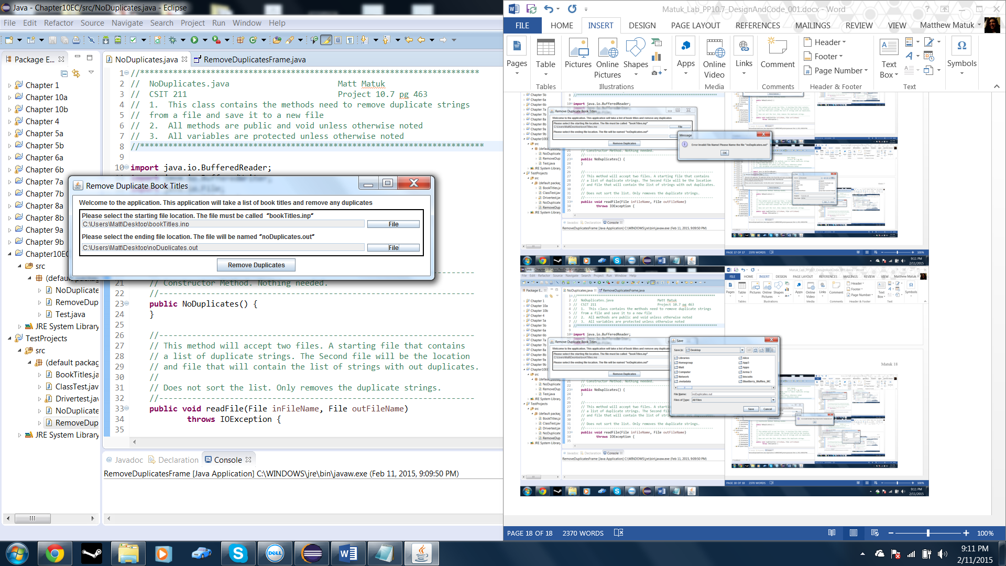

* Pressing the Remove Duplicates button.

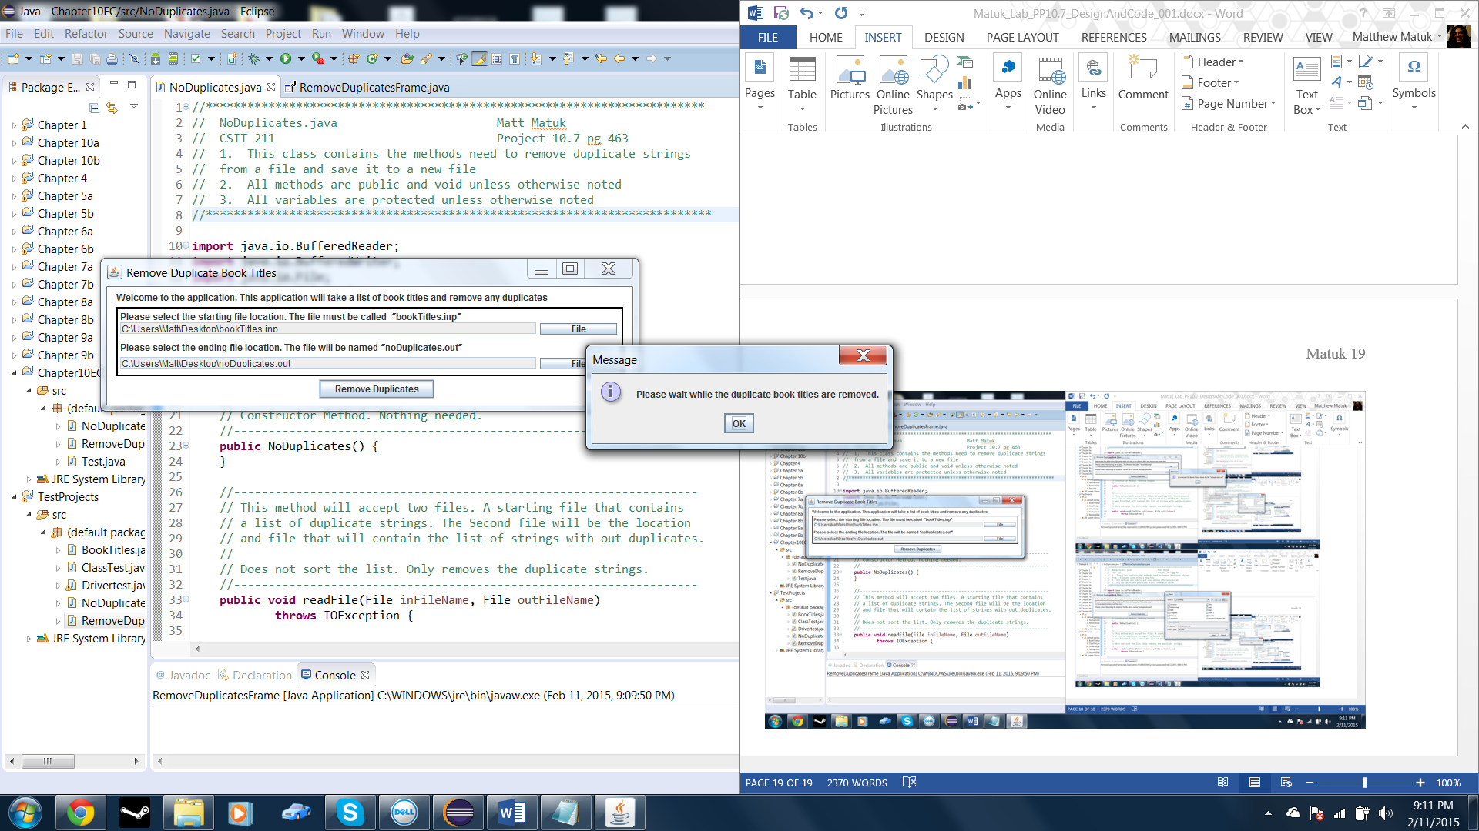

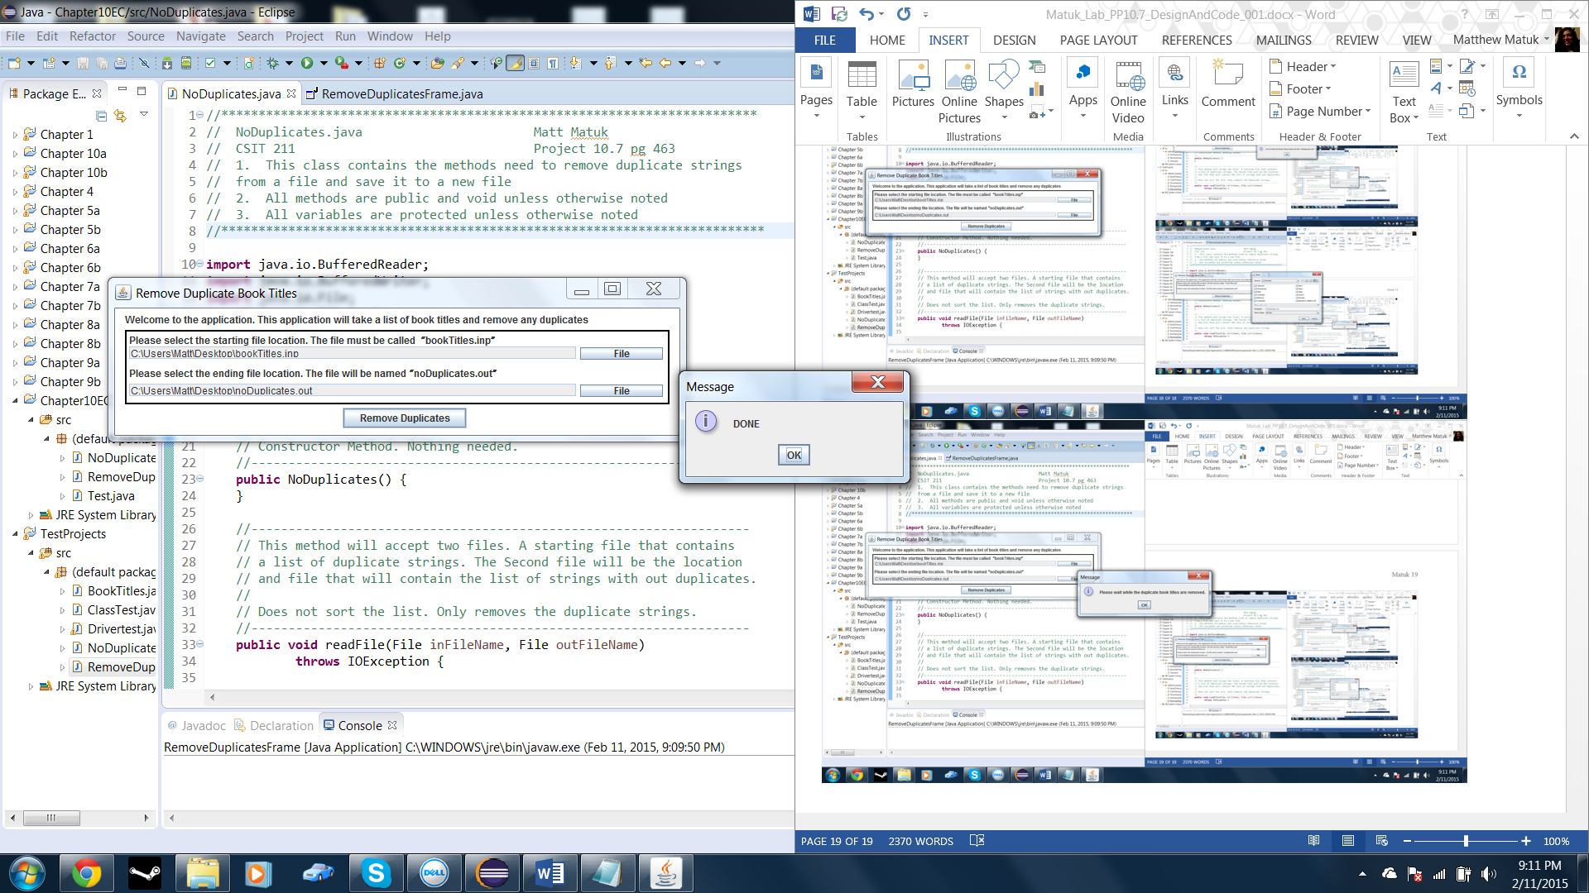

* Pressing the Remove Duplicates button without both file locations chosen.

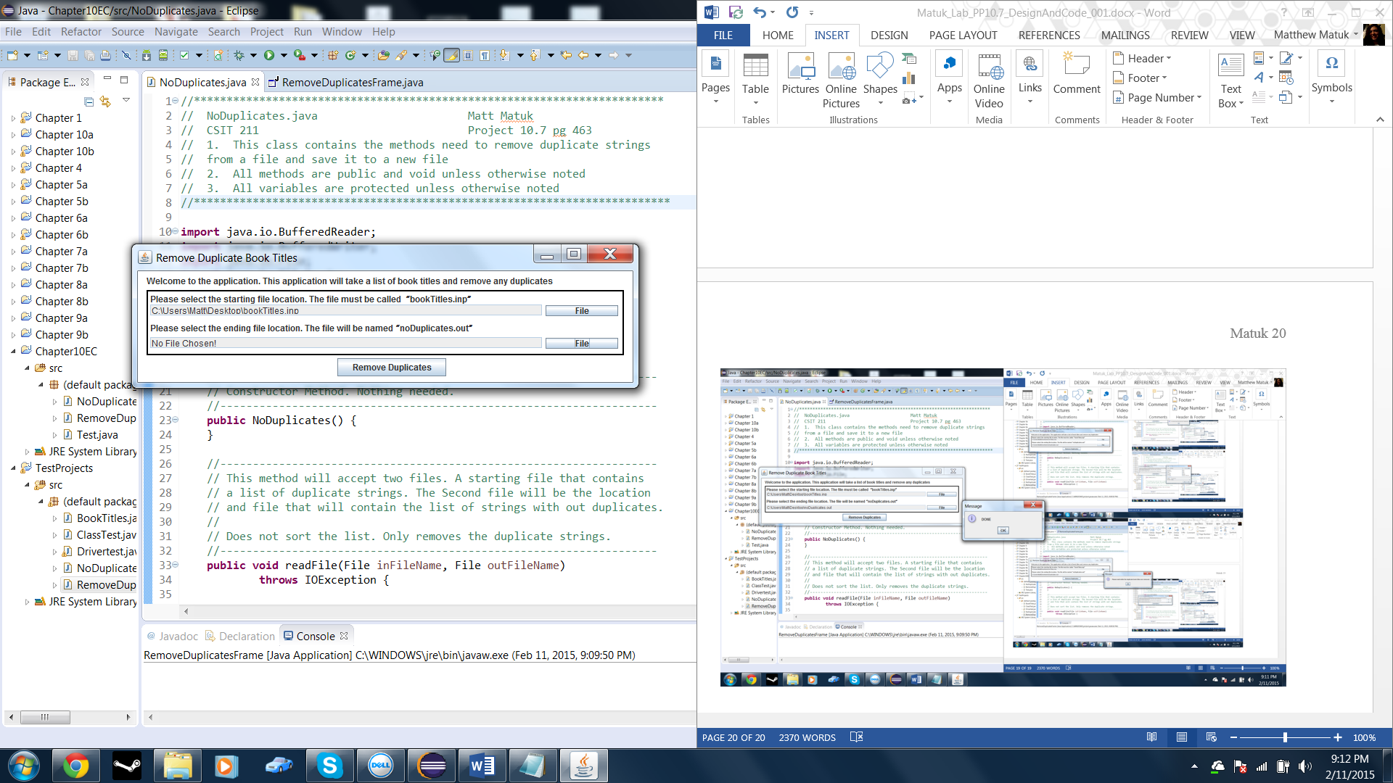

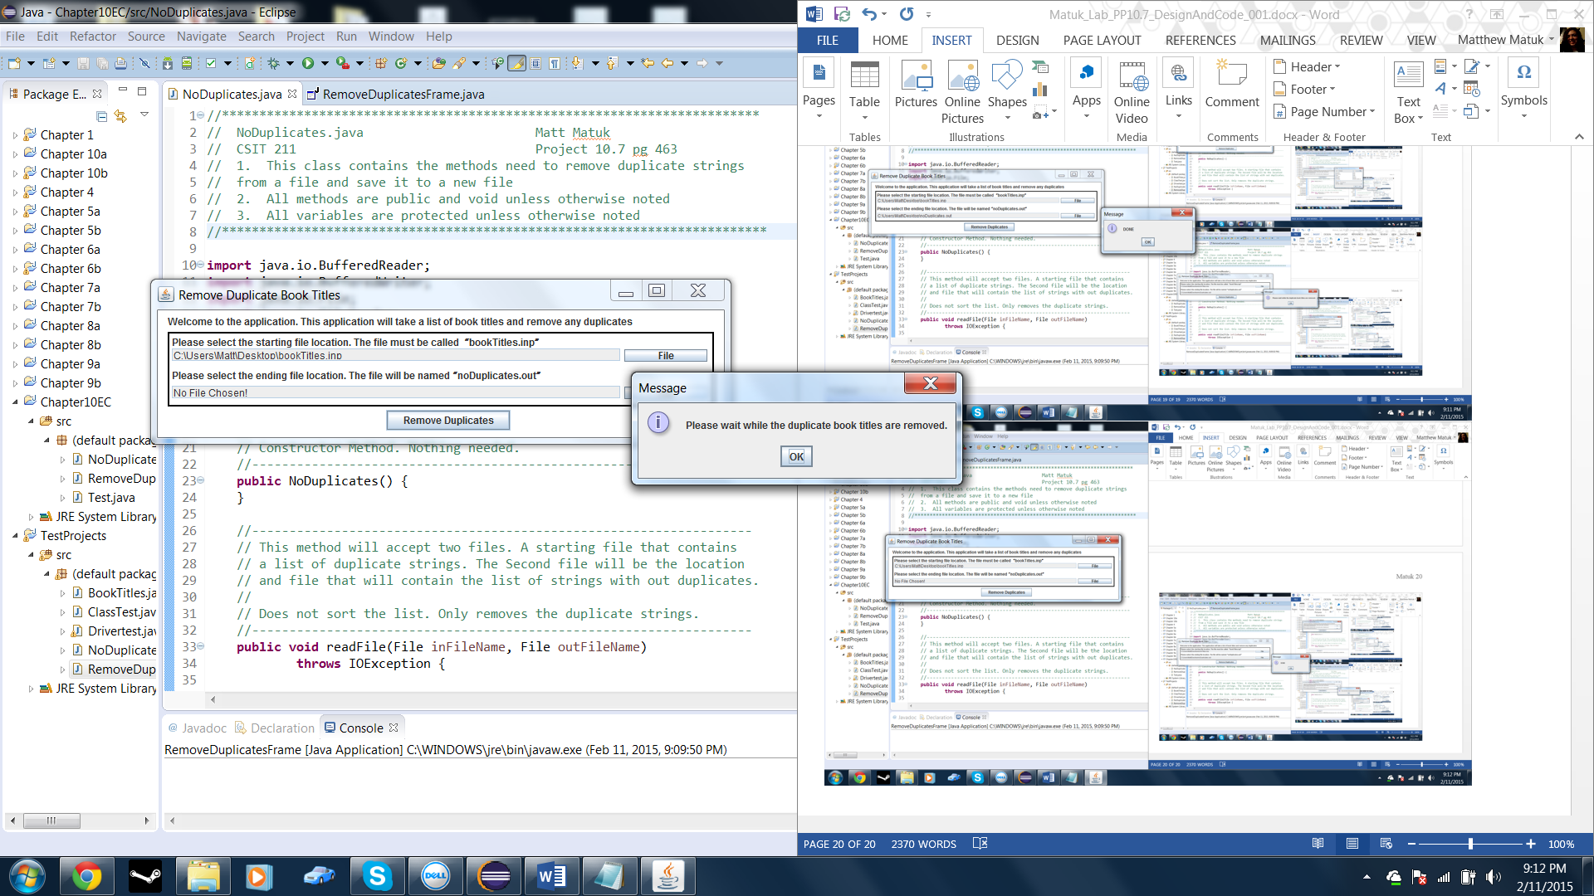

* bookTitle.inp file

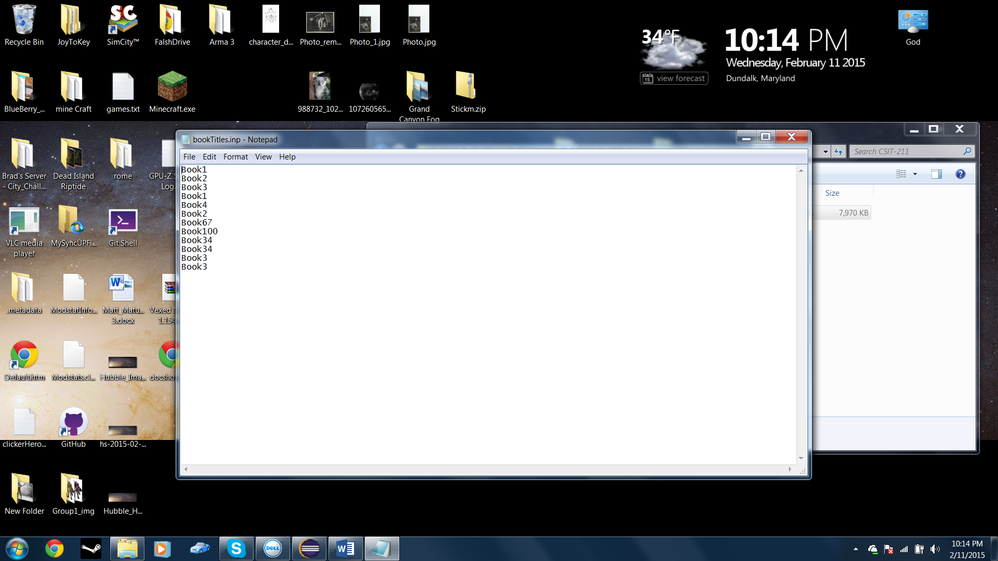

* noDuplicates.out file

